
LITHIUM BATTERY TYPE:ER14335M
ER14335M

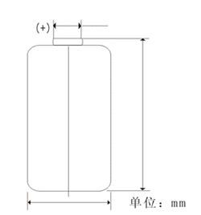
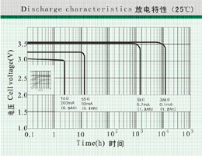
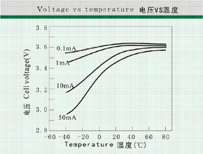
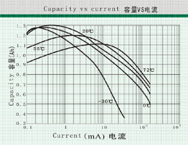
Characteristics
性能数据：
Nominal capacity(0.7mA-2.0V)………………………1300mAh
标称容量
Nominal voltage……………………………………………3.6V
额定电压
Max.constant current……………………………………200mA
最大连续工作电流
Max.pulse current………………………………………400mA
最大脉冲电流
Weight………………………………………………………13g
电池重量
Volume…………………………………………φ14.5×33.5mm
电池尺寸
Workable temperature……………………………-55℃∽+85℃
工作温度
33.5Max
φ14.5Max
φ5.5±0.1
Available terminations:
-/P axial pins
-T/PT2 radial pins
-/PT/TP polarized tabs
极端样式：
-/P 轴向碰焊线
-T/PT2 径向插件
-/PT/TP 多脚插件
Available terminations can be made as requested.
特殊极端样式可按客户要求订做
Caution :Do not make the battery short-circuit,
charge, press ,dissemble ,burn or forcibly it; Do not use new and used batteries together or mix different types of batteries ;Do not reverse the positive and negative pole of battery while using it; Do not solder directly on the battery.
注意：电池正负极之间严禁短路、充电、强迫放电、挤压、拆卸、焚烧；严禁新旧电池或不同类型电池混合使用；严禁电池正、负极直接焊接、严禁电池正、负极反装。
www.nscn.com.cn

